* If any class has one of its method abstract then you must declare entire class abstract.

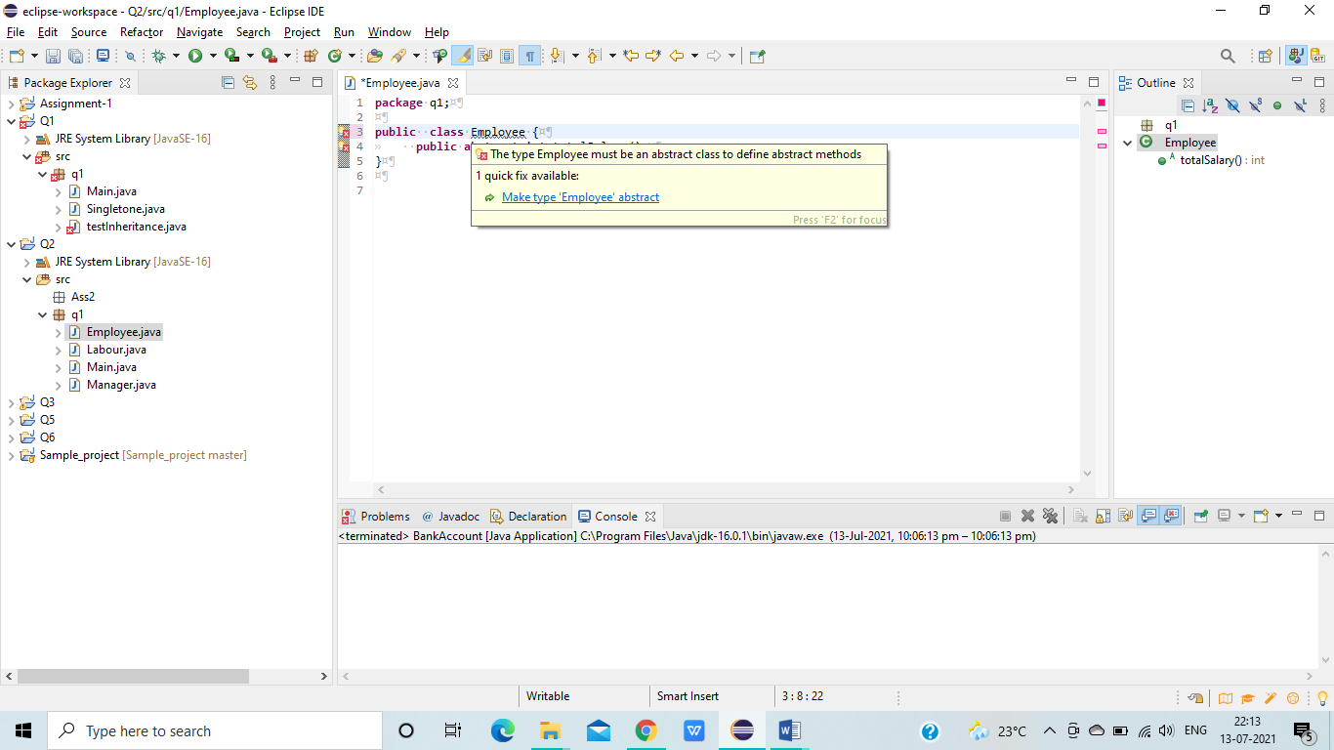

* Abstract class cannot be instantiated.

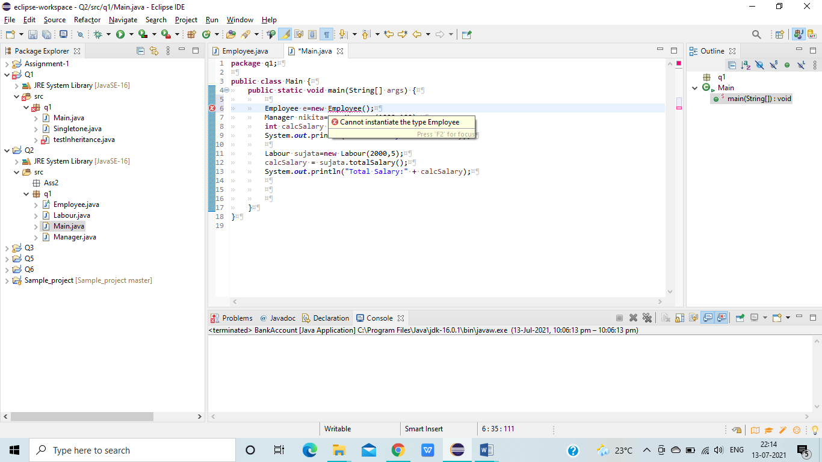

* When we extend an abstract class,we must either override all the abstract methods in sub class or declare subclass as abstract.

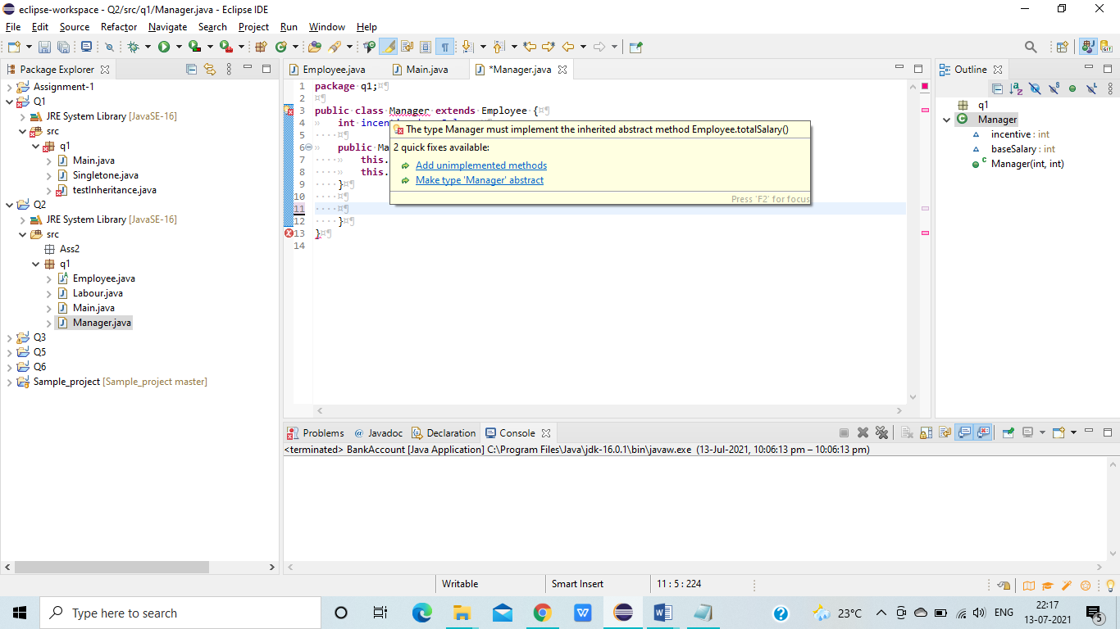

* Abstract class cannot be private.

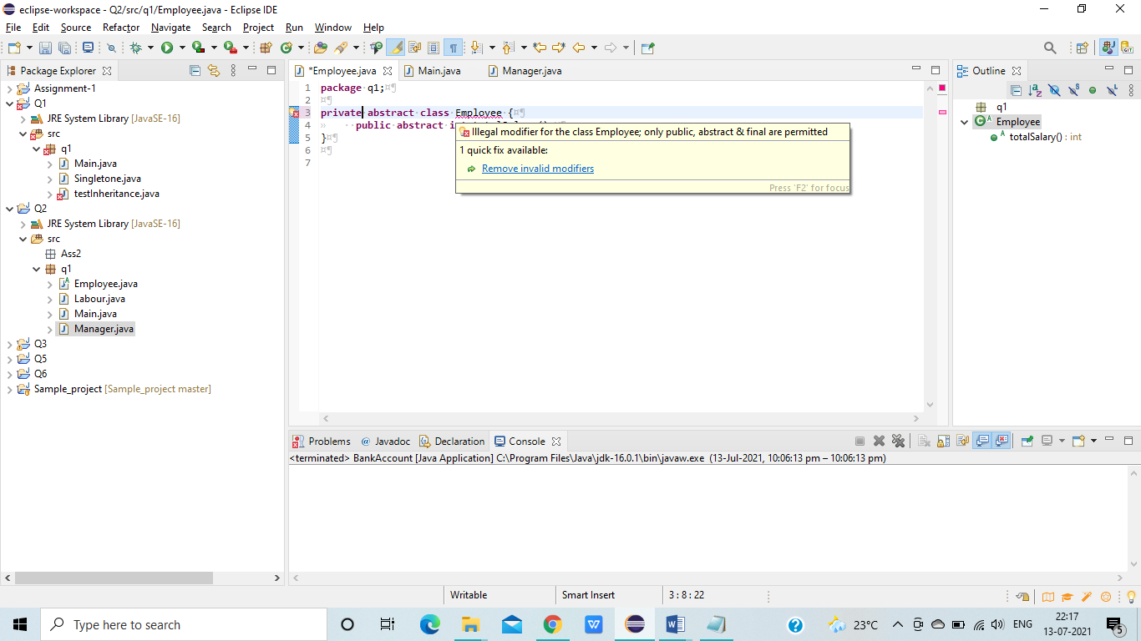

* Abstract class cannot be final.

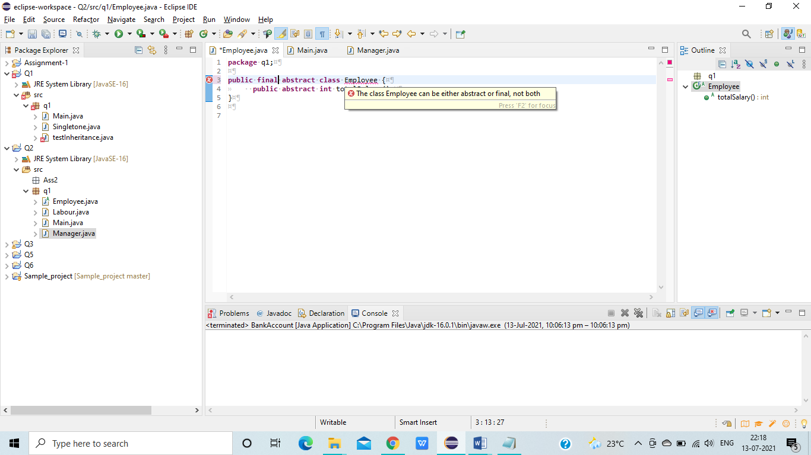

* You can declare a class abstract without having any abstract method.

